Date : 09-08-2021

Session : Table Tag and List Tag

Task given : Create Table and Forms using Table Tag and Div Tag

My Task : Today , I have create Table and From in HTML – TH – TD –TR – ETC

Form 01 :-

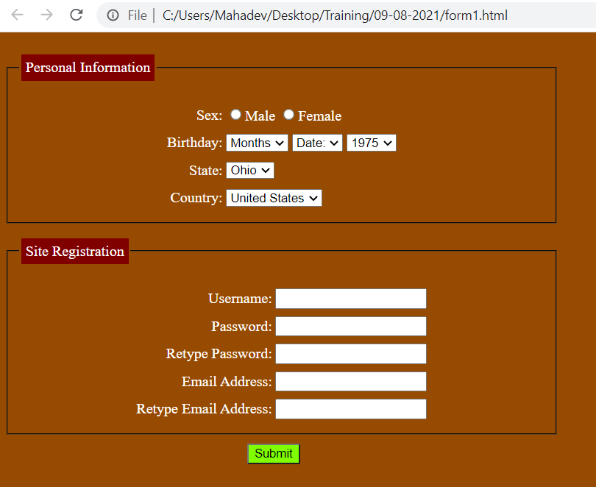

Form :- 02

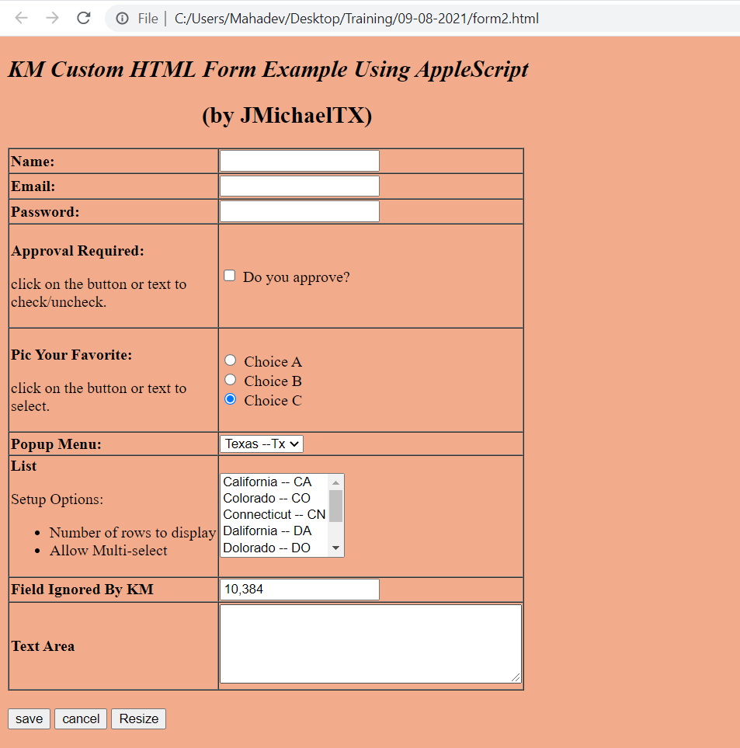

Form 03 :-

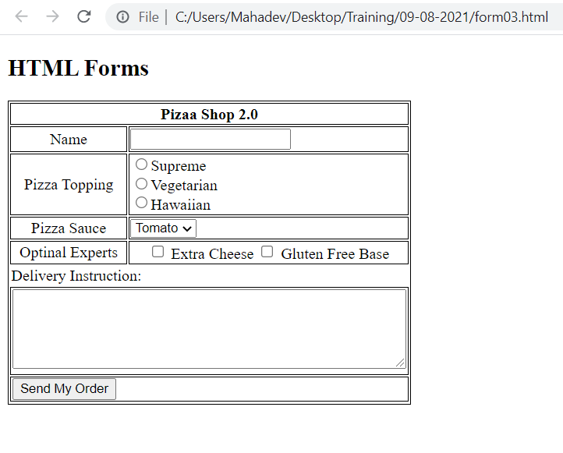

Table 01 :

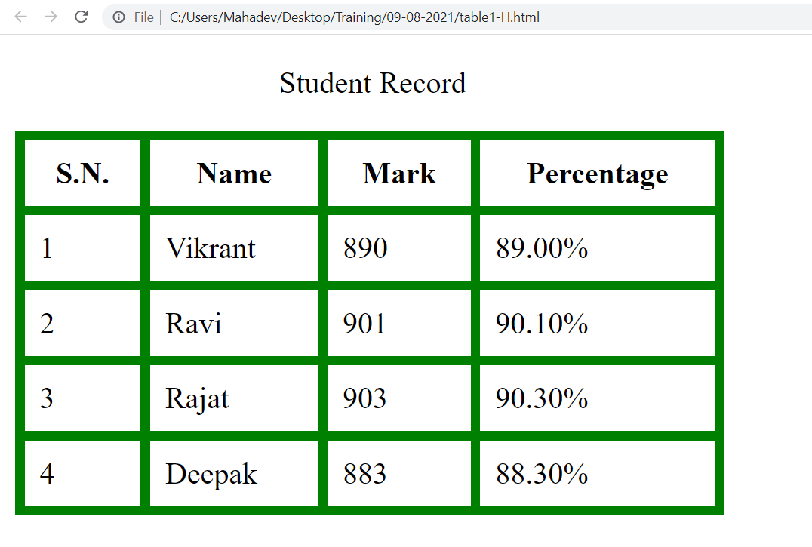

Table 02 :

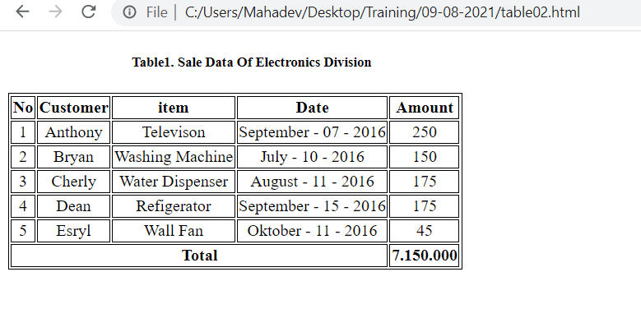

Table 03 :

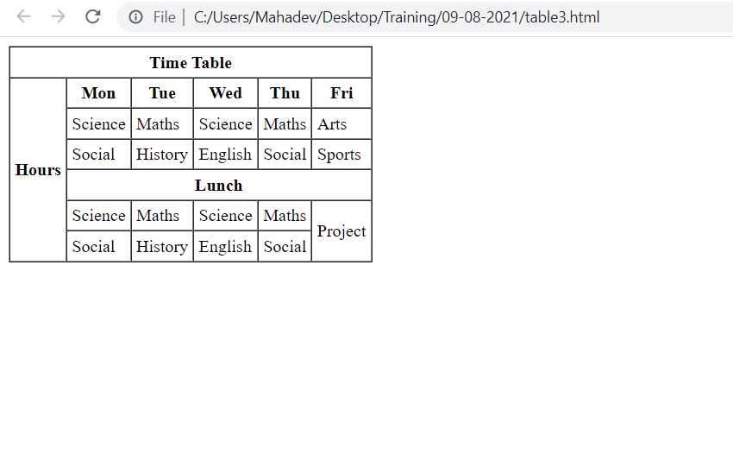

Table 04 : 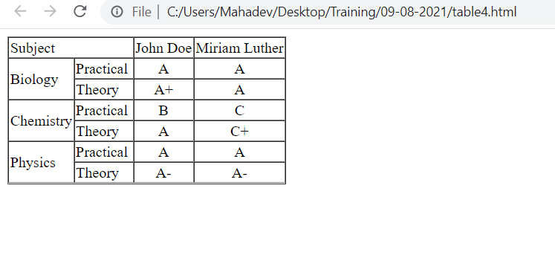

Table 05 : 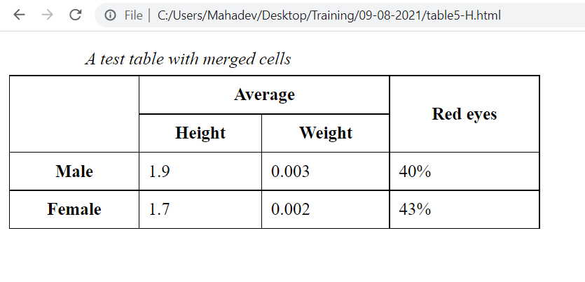

Table 06 : 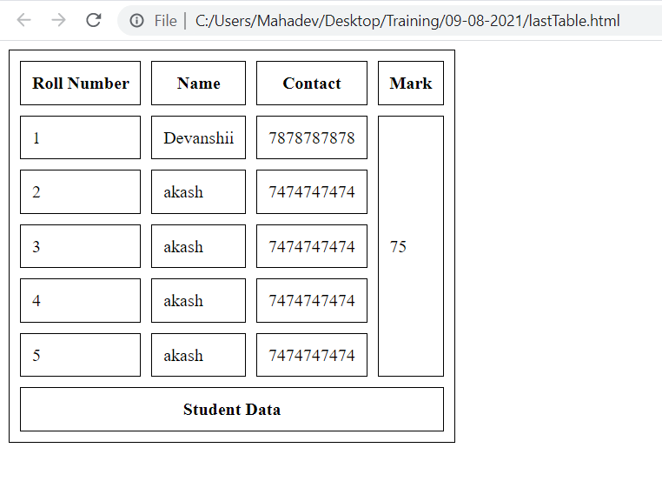

Li

List 01

